
STUDENT: MICHAEL ASILWA
ADMISSION: BSCCS/2024/56330
COURSE: COMPUTER SCIENCE
UNIT CODE: BIT4138
UNIT NAME: ADVANCED CRYPTOGRAPHY
LECTURER NAME: Michael Nyoro
ACADEMIC YEAR: Year 3 semester 2
PROJECT DETAILS
PROJECT TITLE: SECURE FILE ENCRYPTION AND MESSAGING SYSTEM
SELECTED TECHNOLOGIES:
Python + cryptography libraries
OpenSSL + Linux
GITHUB REPOSITORY LINK: https://github.com/xxplosi/Advanced-cryptography

Contents
WEEK ONE: CRYPTOGRAPHY ENVIRONMENT SETUP 4
Title: installation and configuration of cryptography development environment 4
FIG 1: python and vs code installation 4
FIG 2: cryptography libraries installed 4
FIG 3: OpenSSL installation Test 5
FIG 4: local encryption script 5
FIG 5: GitHub repository initialization 6
STUDENTS REFLECTION 6
WEEK 2: CLASSICAL CRYPTOGRAPHY AND CIPHER DESIGN 6
Title: implementation of classical encryption algorithm’s 6
FIG 1: Caesar cipher implementation 7
FIG 2: Vigenère cipher encryption process 7
FIG 3: encryption and decryption output 7
FIG 4: user input validation interface 8
FIG 5: cipher testing results 8
STUDENTS REFLECTION 8
WEEK 3: STREAM CIPHERS AND RANDOMNESS TESTING 9
Tittle: implementation of stream cipher systems and random sequence analysis 9
FIG 1: LFSR generator implementation 9
FIG 2: pseudorandom sequence output 9
FIG 3: statistical randomness testing 10
FIG 4: RC4 stream cipher simulation 10
FIG 5: Encryption performance results 11
STUDENTS REFLECTION 11
WEEK 4: BLOCK CIPHER DESIGN AND AES 12
Title: AES and block cipher operations 12
FIG 1: AES encryption 12
FIG 3: file encryption demonstration 13
FIG 4: Decryption results 13
FIG 5: performance testing 14
STUDENTS REFLECTION 14
WEEK 5: PUBLIC KEY CRYPTOGRAPHY 14
Title: implementation of RSA encryption and key management 14
FIG 1: RSA key pair generation 15
FIG 2: public key encryption process 15
FIG 3: private key decryption results 15
FIG 4: secure message transmission 16
FIG 5: RSA testing and validation 16
STUDENTS REFLECTION 16
CREATIVE TASK 17

WEEK ONE: CRYPTOGRAPHY ENVIRONMENT SETUP

Title: installation and configuration of cryptography development environment
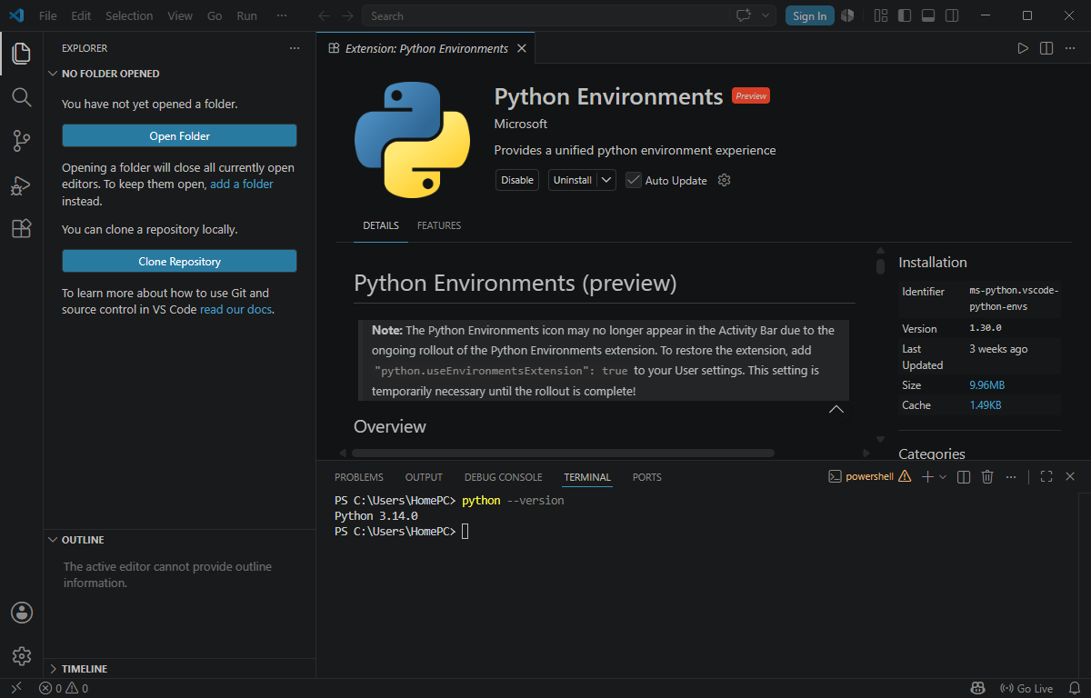

FIG 1: python and vs code installation
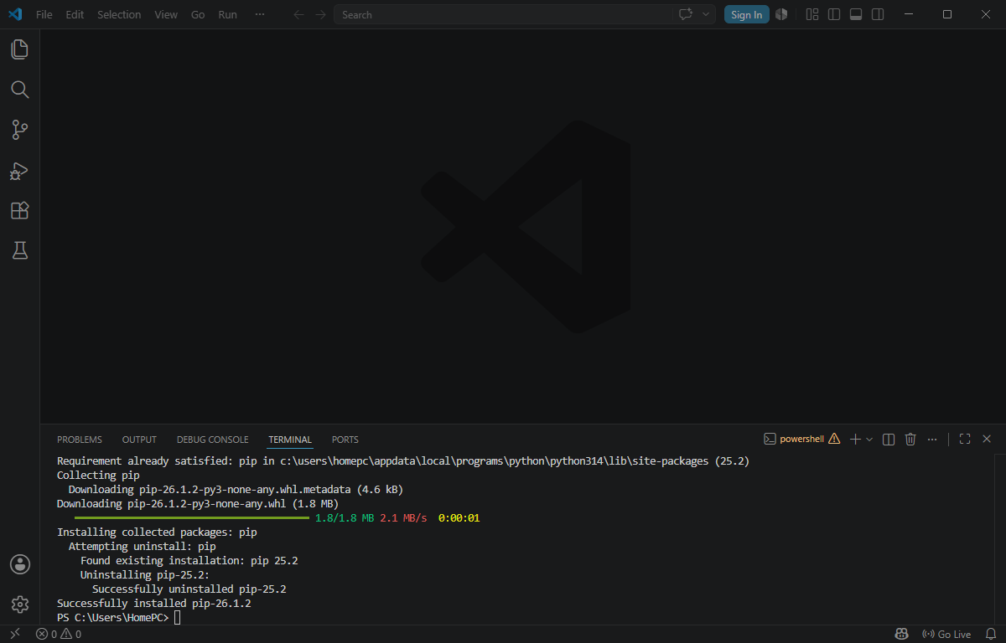

FIG 2: cryptography libraries installed

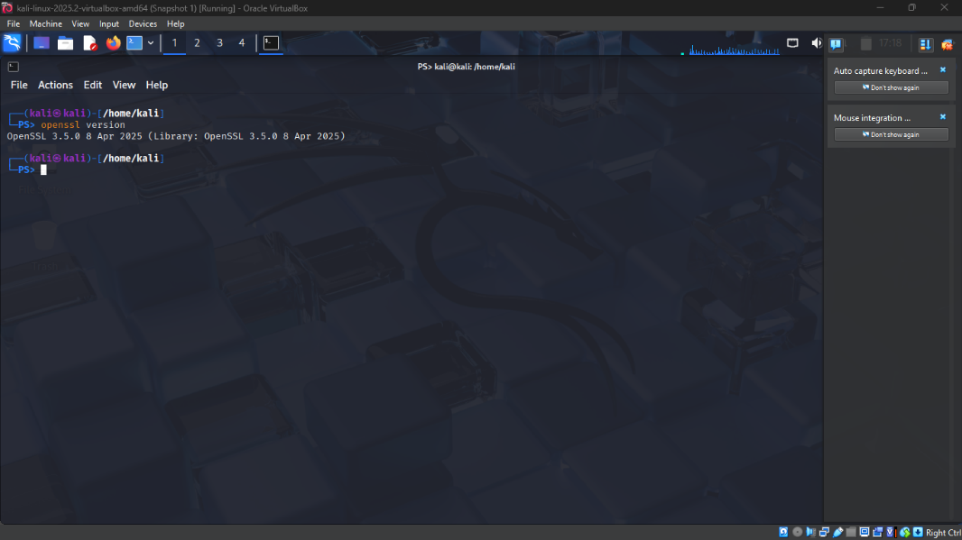

FIG 3: OpenSSL installation Test
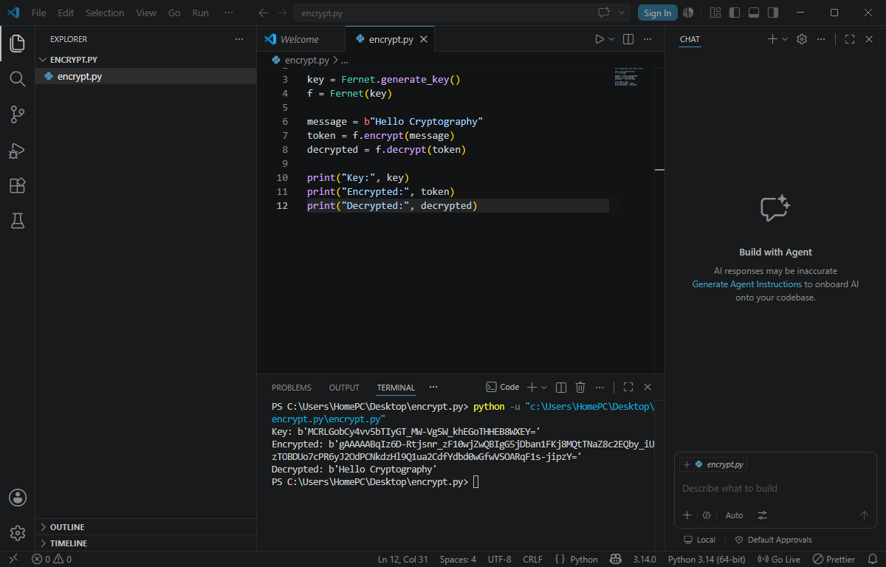

FIG 4: local encryption script

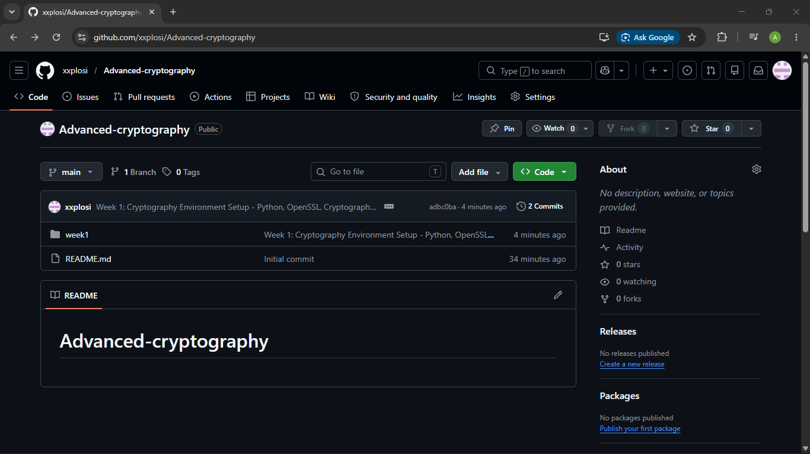

FIG 5: GitHub repository initialization

STUDENTS REFLECTION
During this task I understood initializing a GitHub repository together with the installation of cryptography libraries. I did not encounter any challenges as the installation was easy

WEEK 2: CLASSICAL CRYPTOGRAPHY AND CIPHER DESIGN

Title: implementation of classical encryption algorithm’s
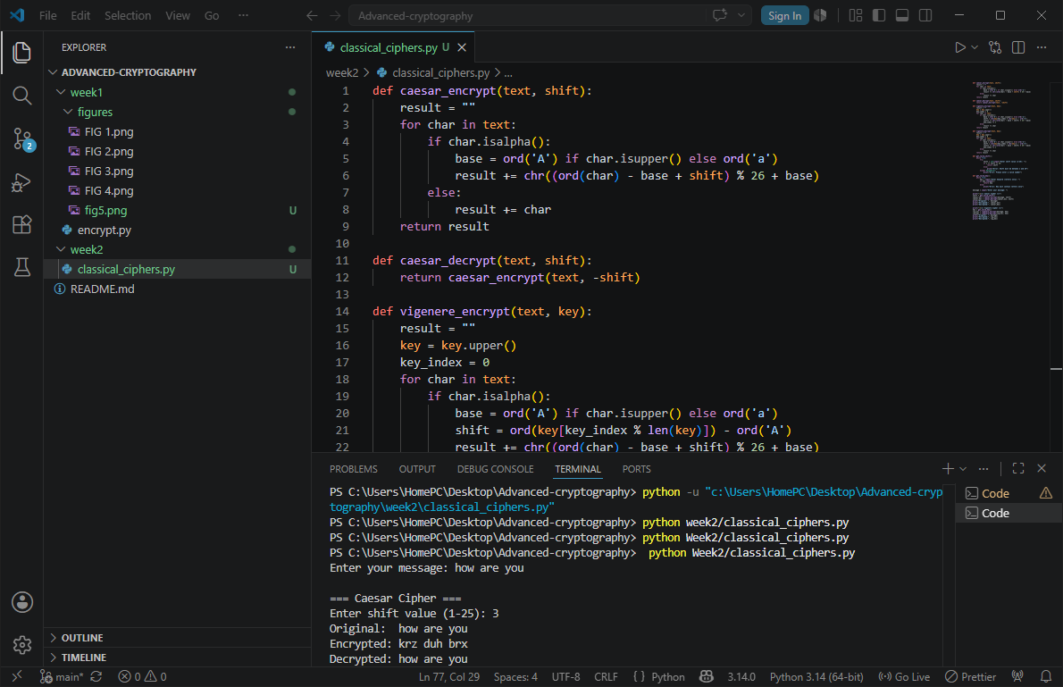

FIG 1: Caesar cipher implementation
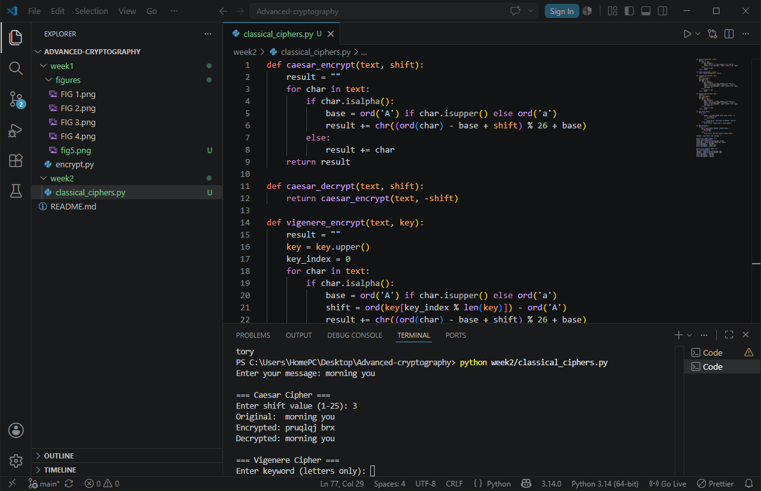

FIG 2: Vigenère cipher encryption process

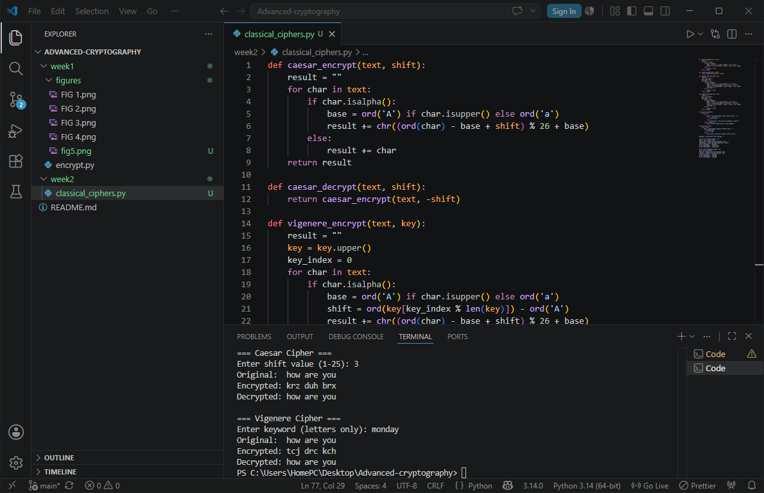

FIG 3: encryption and decryption output

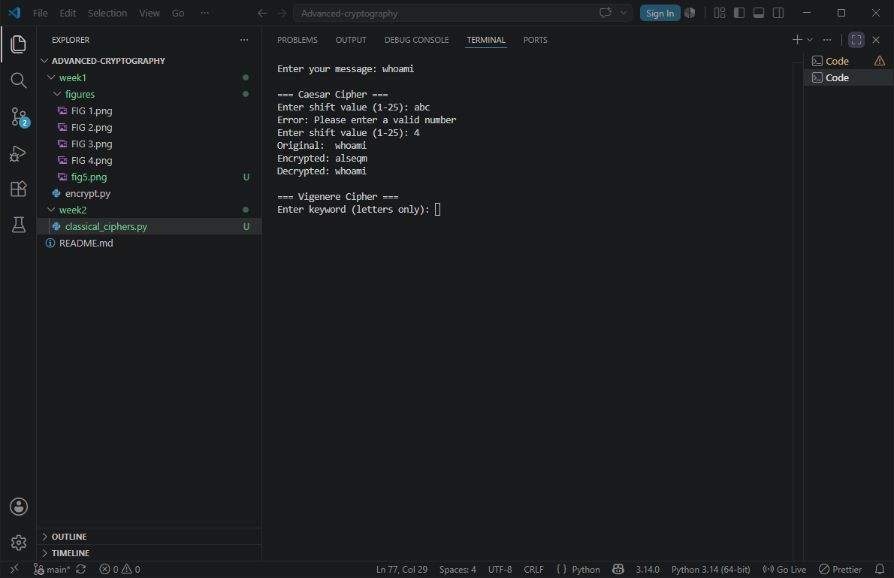

FIG 4: user input validation interface

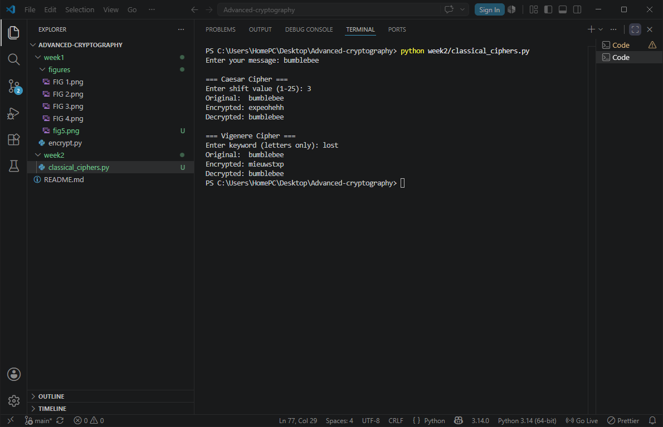

FIG 5: cipher testing results

STUDENTS REFLECTION
Caesar shifts each letter by a fixed number, Vigenère shifts each letter by a different amount based on a keyword. Encryption workflow: plaintext → key → ciphertext → reverse → plaintext back.
Caesar is weaker than Vigenère since it only has 25 possible shifts

WEEK 3: STREAM CIPHERS AND RANDOMNESS TESTING

Tittle: implementation of stream cipher systems and random sequence analysis
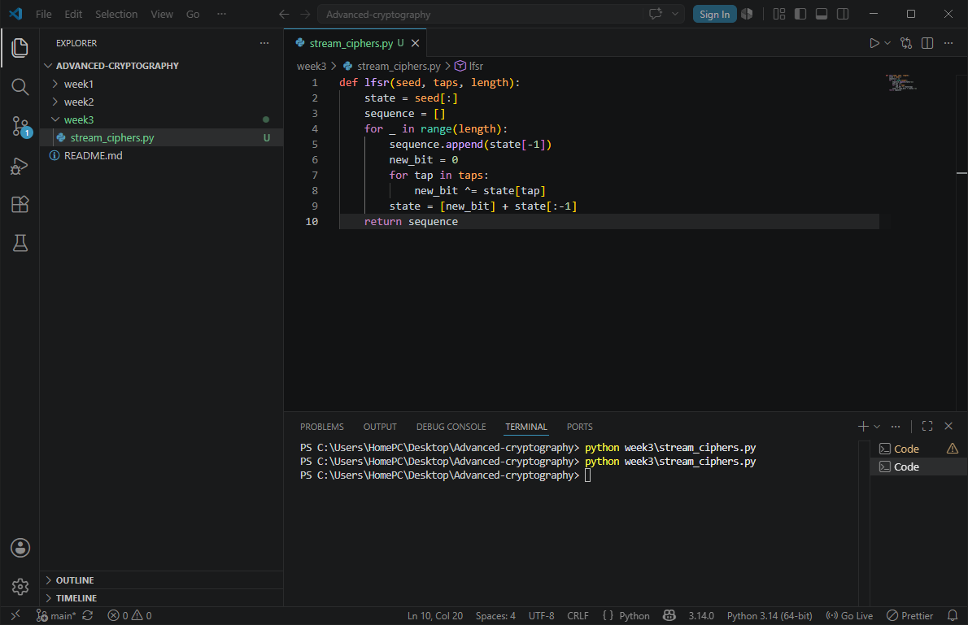

FIG 1: LFSR generator implementation
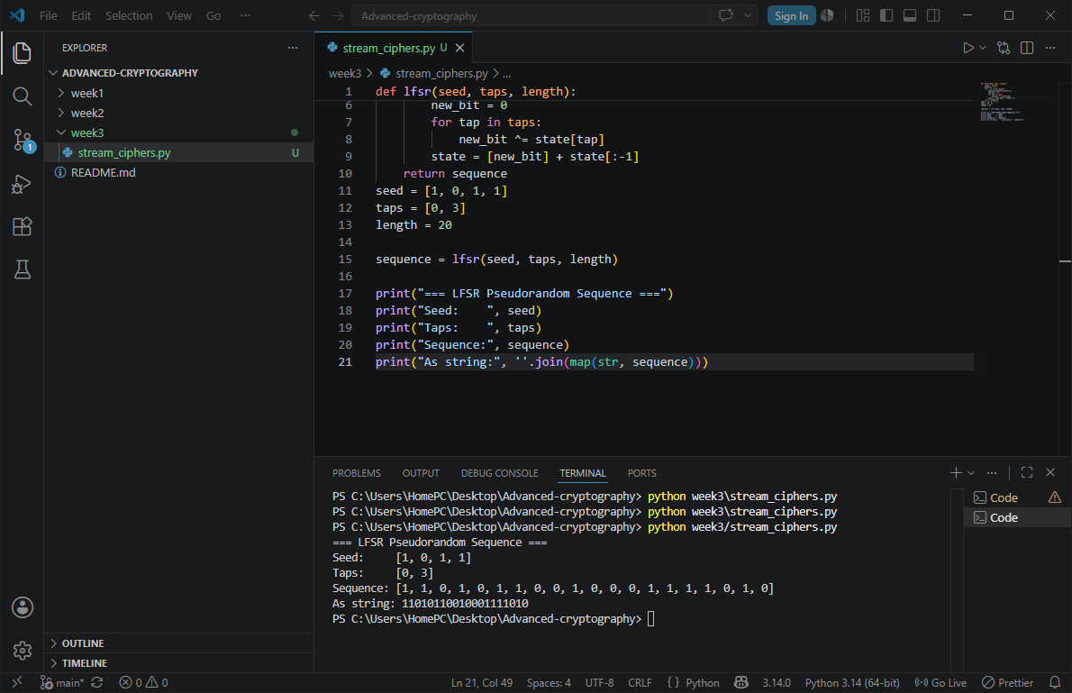

FIG 2: pseudorandom sequence output

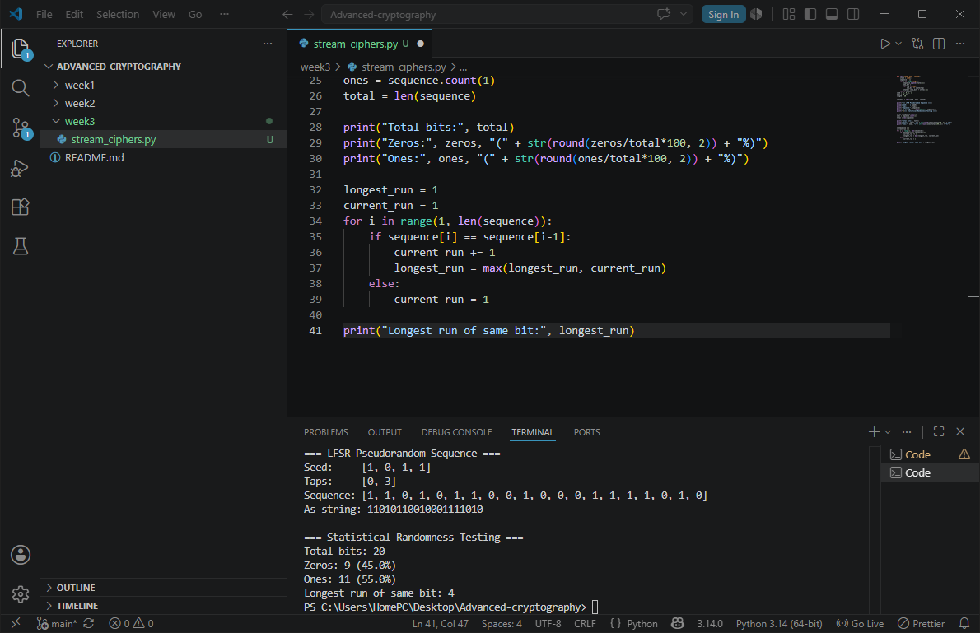

FIG 3: statistical randomness testing
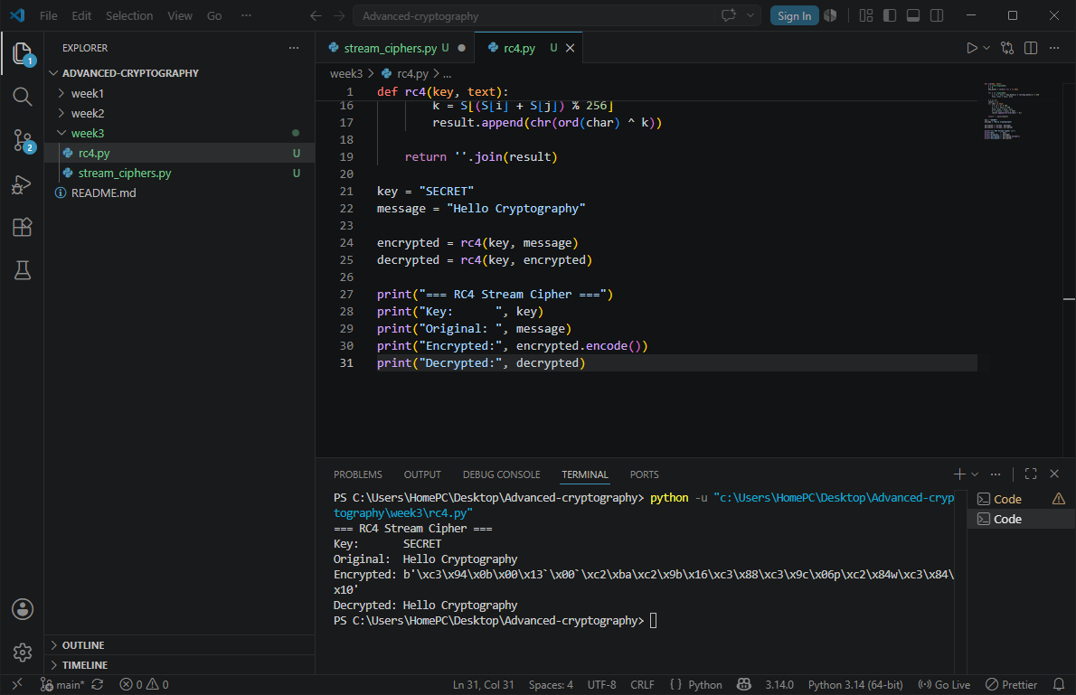

FIG 4: RC4 stream cipher simulation

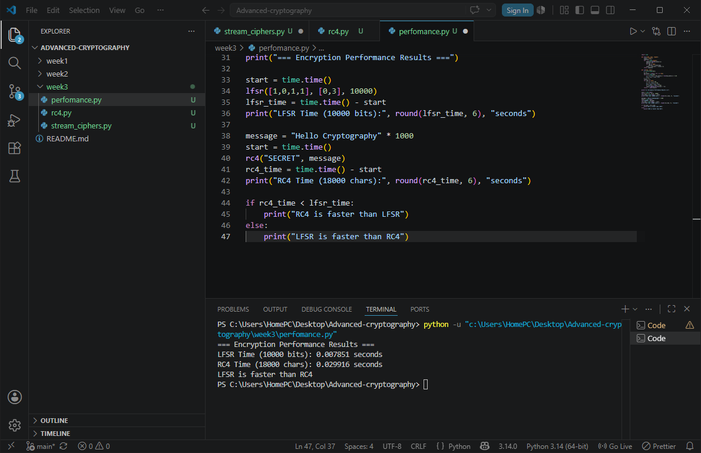

FIG 5: Encryption performance results

STUDENTS REFLECTION
I learnt how stream ciphers encrypt data one bit at a time using pseudorandom keystreams
LFSR generates pseudorandom bits using XOR and nit shifting from a seed value
Short seeds and repeated keystreams are some of the weaknesses in security.

WEEK 4: BLOCK CIPHER DESIGN AND AES

Title: AES and block cipher operations
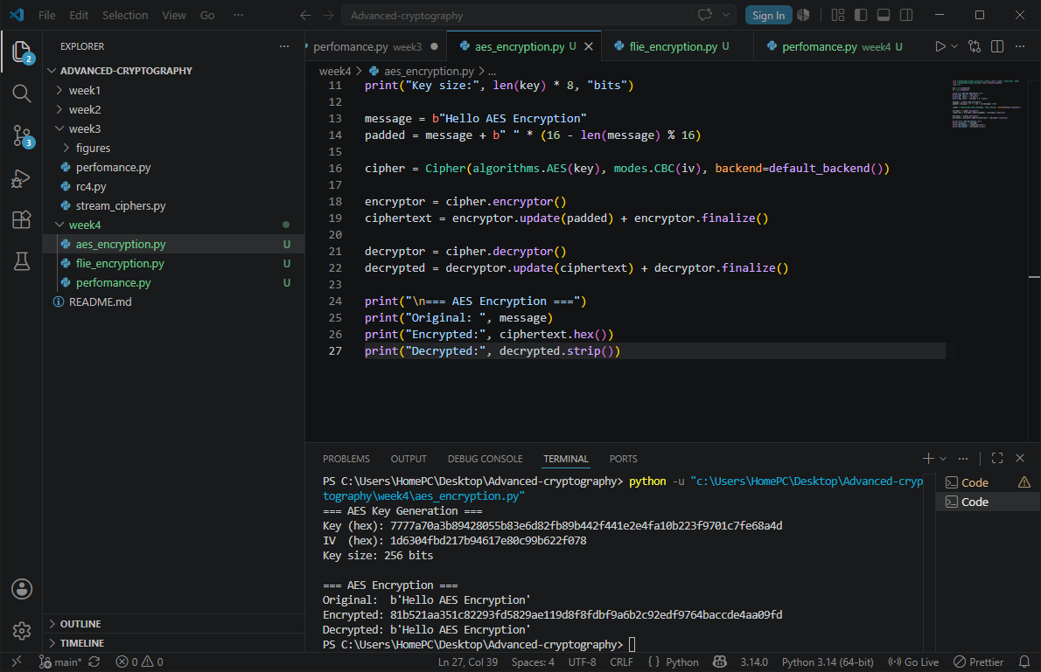

FIG 1: AES encryption

FIG 2: key generation process

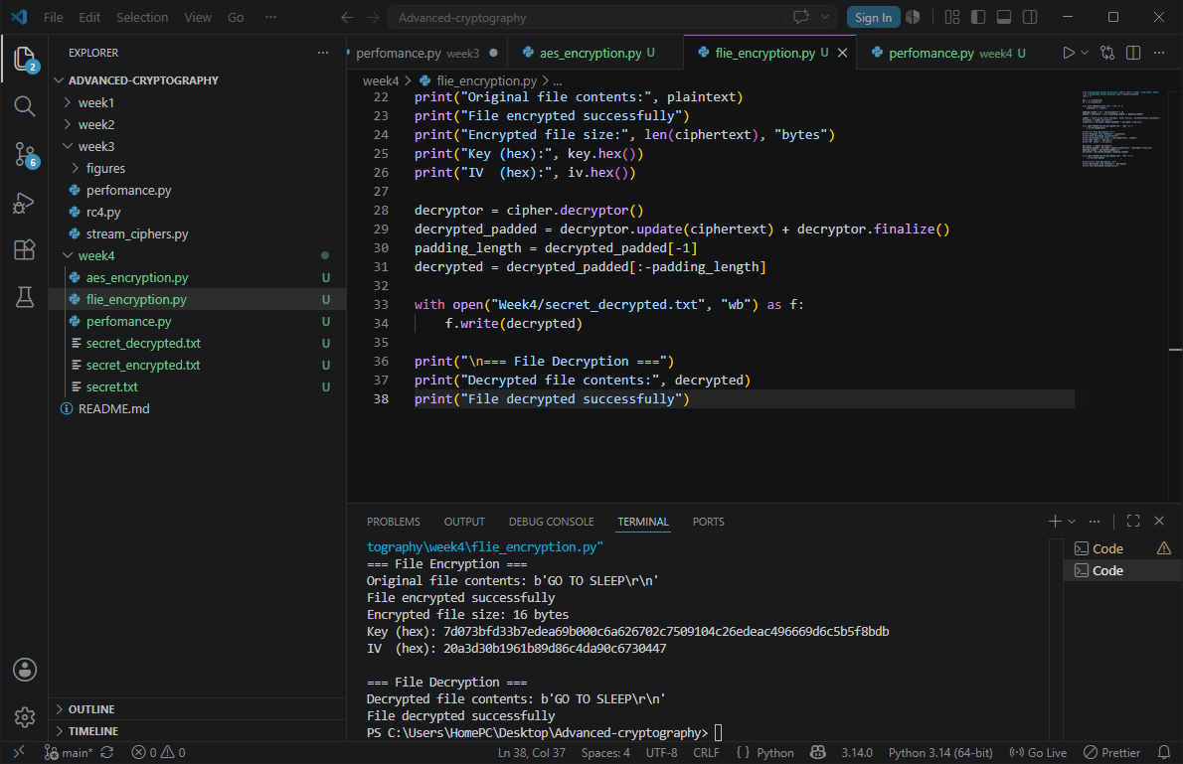

FIG 3: file encryption demonstration


FIG 4: Decryption results

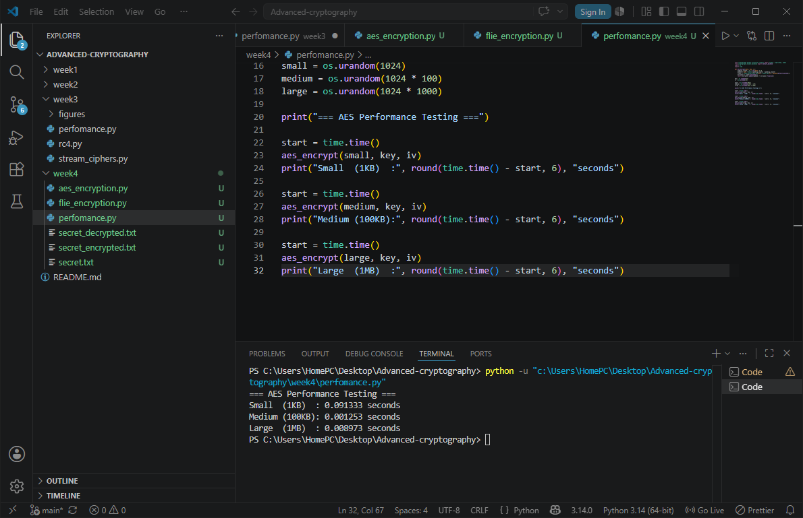

FIG 5: performance testing

STUDENTS REFLECTION
Learnt that AES encrypts data in 128-bit blocks using multiple rounds of substitution,
Sifting and XOR operations. Challenge encountered was handling the padding to meet AES block size requirements.

WEEK 5: PUBLIC KEY CRYPTOGRAPHY

Title: implementation of RSA encryption and key management
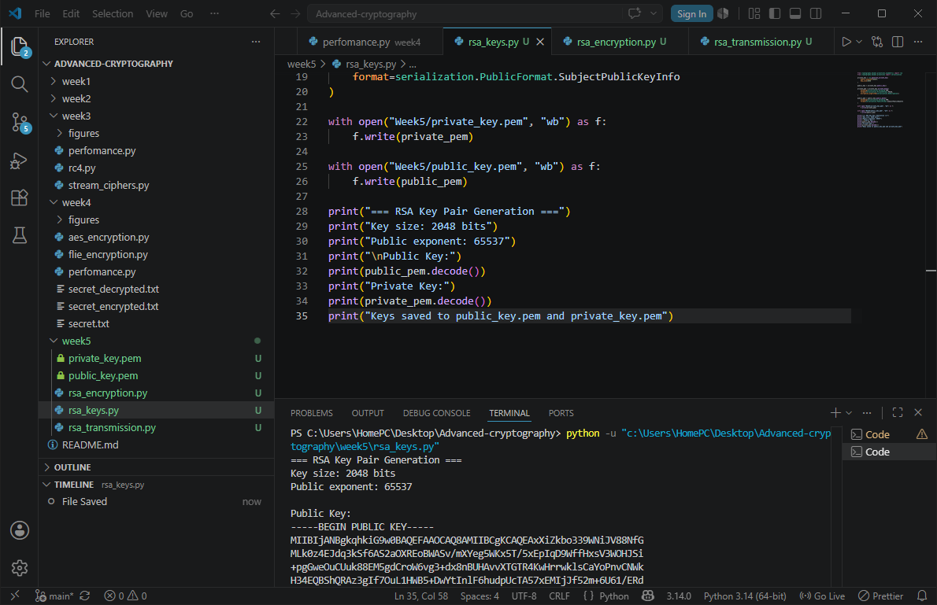

FIG 1: RSA key pair generation
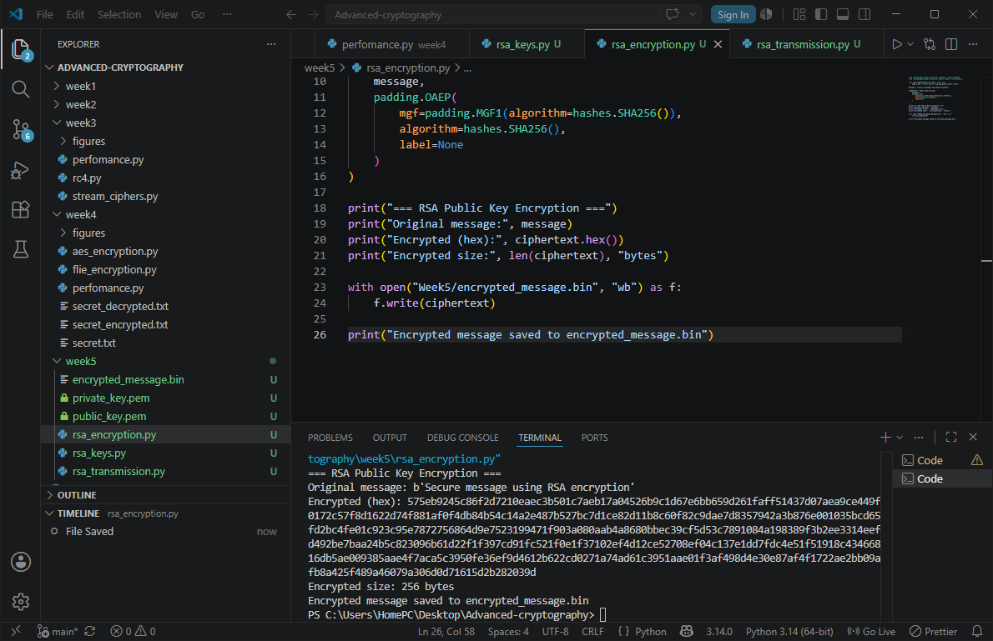

FIG 2: public key encryption process
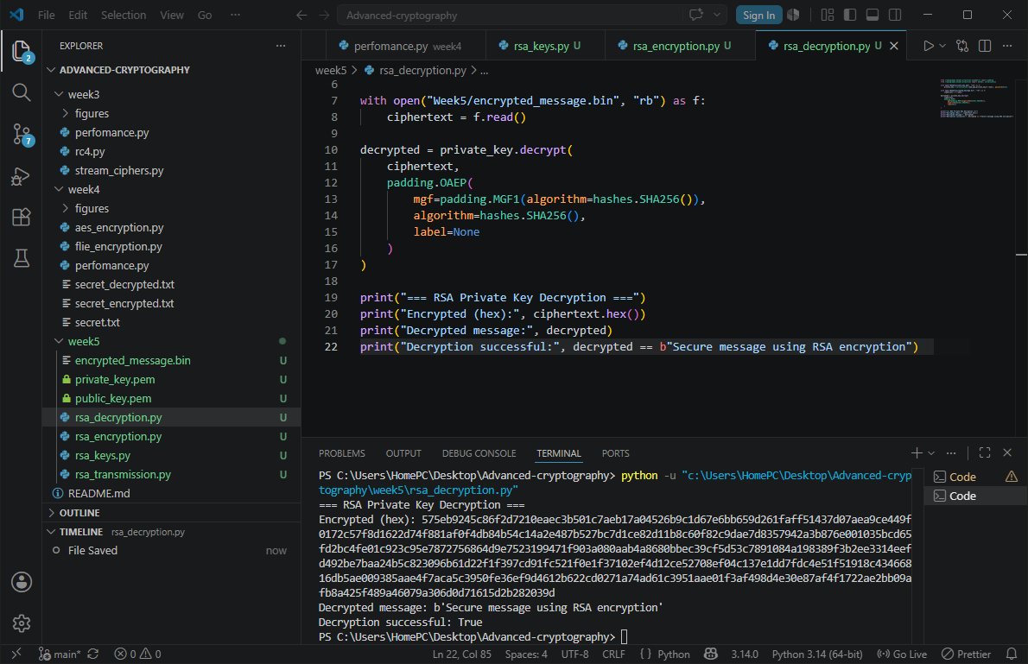

FIG 3: private key decryption results

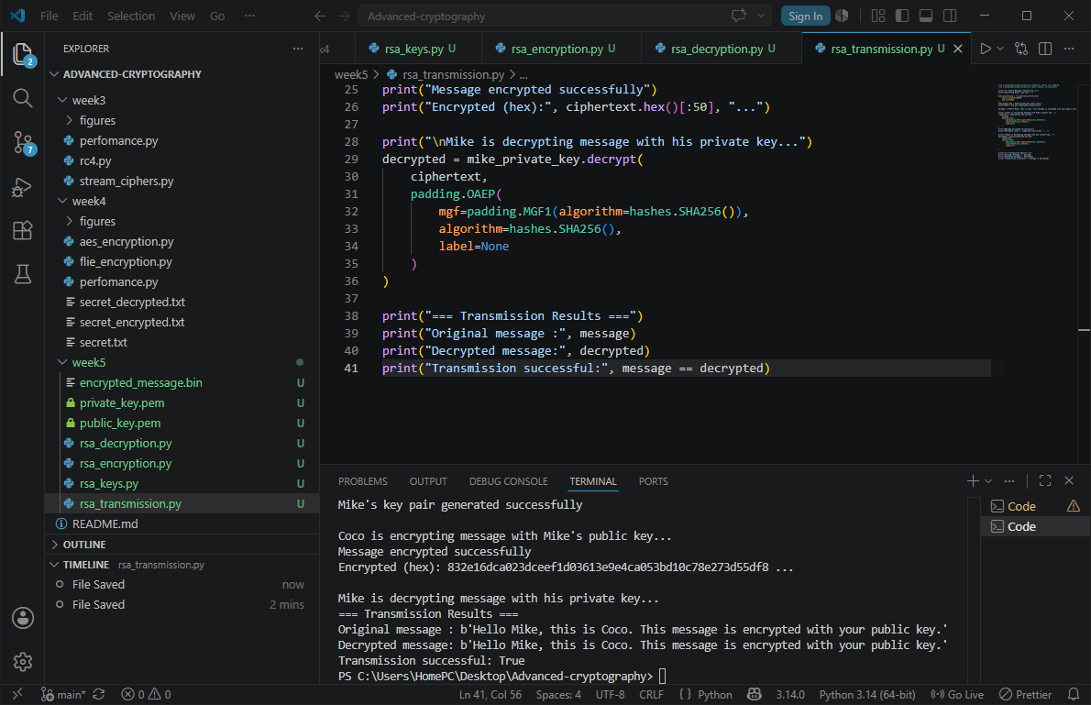

FIG 4: secure message transmission
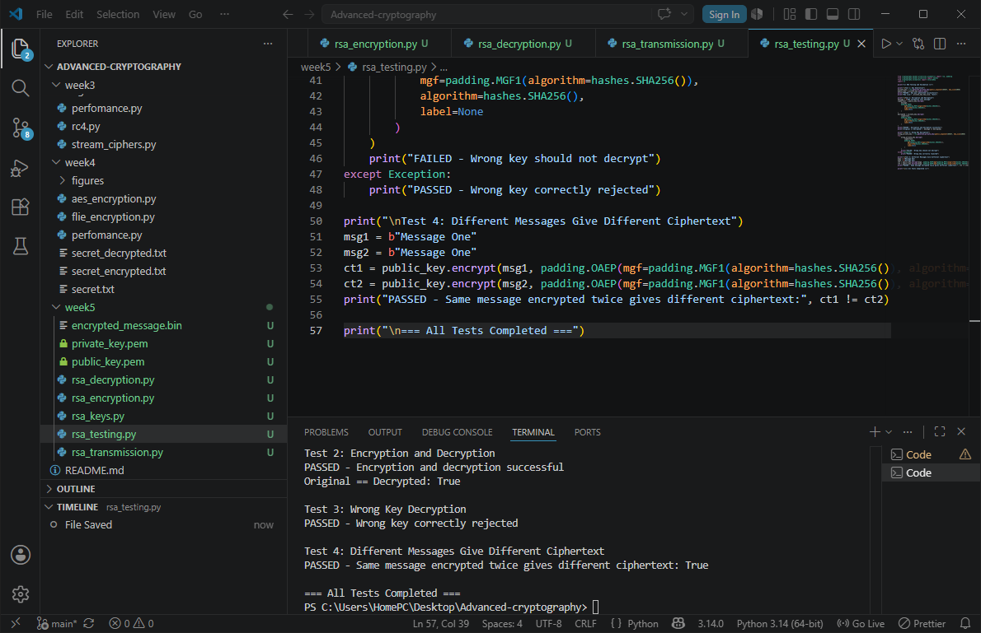

FIG 5: RSA testing and validation

STUDENTS REFLECTION
RSA uses public and private key for encryption and decryption unlike symmetric which uses one for both.
The public key is shared openly while the private key stays secretly

CREATIVE TASK
A secure chat simulator where a user can choose an encryption method ,type a message and see it encrypted and decrypted
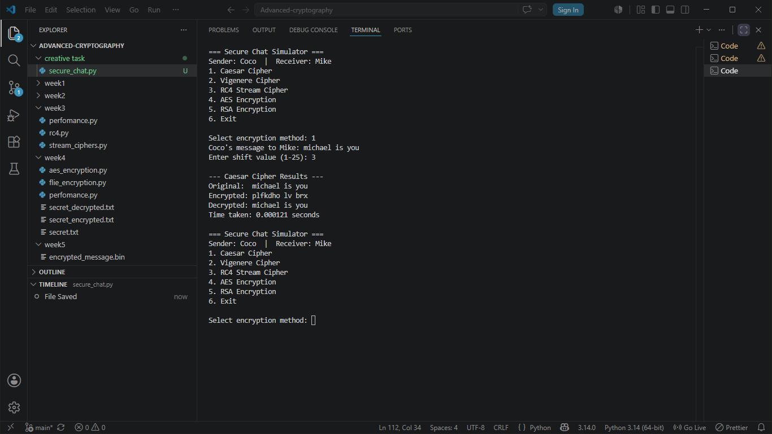

FIG 6 : RESULTS OUTPUT

